Project 1

Daniel Koman

University of Advancing Technology - SCI388

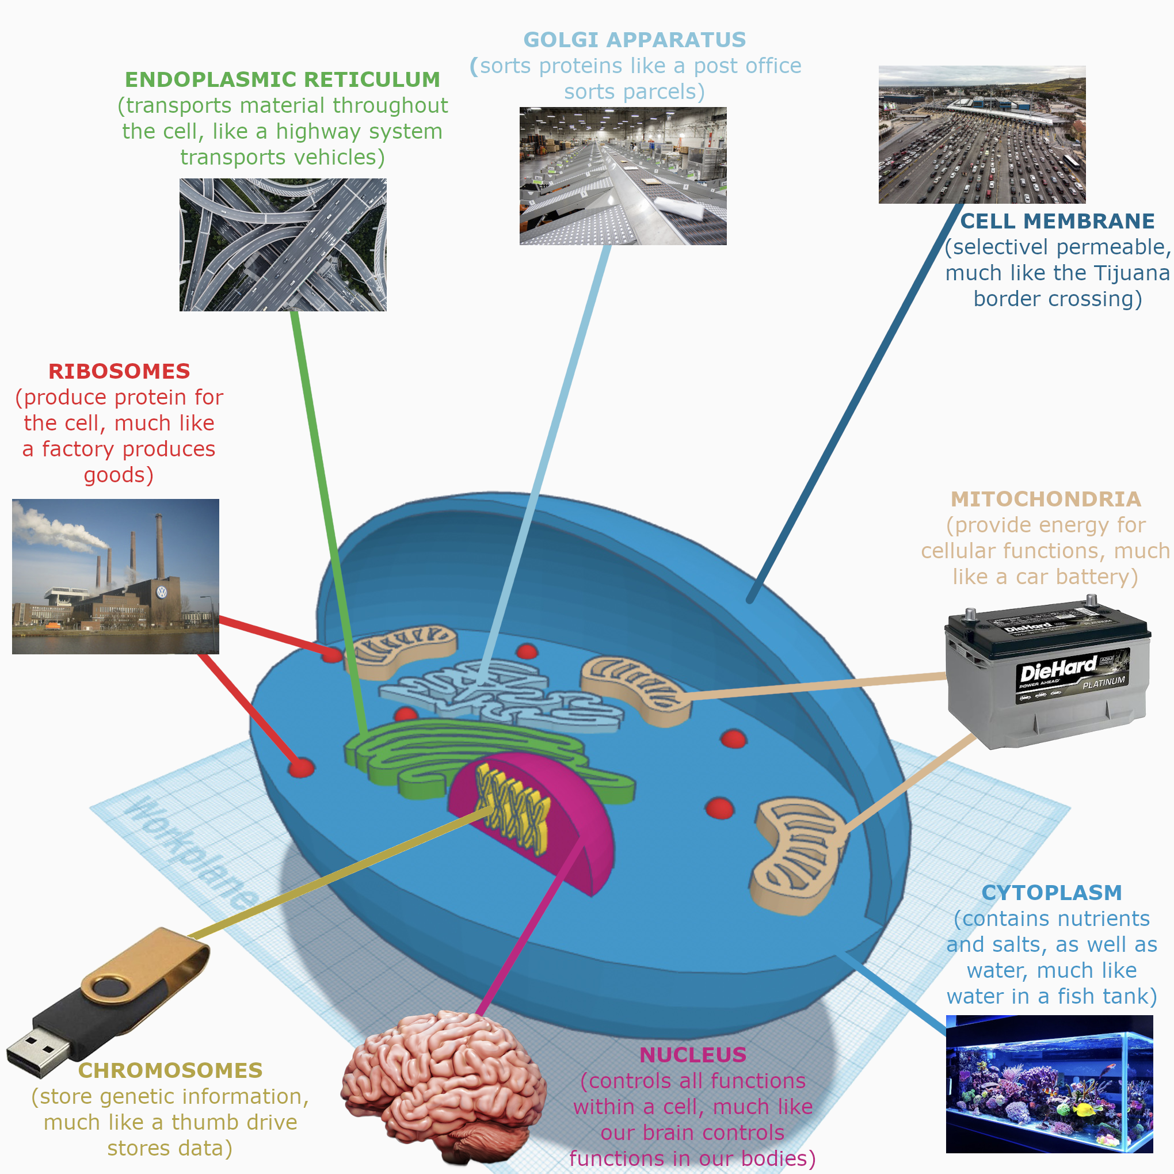

Project 1

The various structures within the animal cell are analogous to real-world objects in various ways. The cell membrane, for instance, is “selectively permeable, meaning it only allows certain molecules to enter and exit” (McLaughlin, 2020). In this way, it’s similar to the Tijuana border crossing as depicted in the thumbnail (Lind, 2019). The cytoplasm contains cytosol, which “consists primarily of water, but also contains ions, proteins, and small molecules” (McLaughlin, 2020). In this way, it’s similar to the saltwater in a saltwater fish tank as depicted in the thumbnail (crystal_oceans, 2021). The mitochondria “are the energy-producing organelles, commonly known as “the powerhouse of the cell” (McLaughlin, 2020). Because they provide energy for cellular functions, mitochondria are analogous to a car battery as depicted in the thumbnail (Advance Auto Parts, 2022). Ribosomes “are like mini machines that synthesize all the proteins in the cell” (McLaughlin, 2020). In that they are constantly producing proteins for use by other organelles within the cell, ribosomes can be thought of as miniature factories, as depicted in the thumbnail (Wikipedia 2022).

The endoplasmic reticulum is “involved in the production, processing, and transport of proteins” (McLaughlin, 2020). They transport proteins throughout the cell similar to how highway systems transport vehicles, as seen in the thumbnail (Safety+Health, 2021). The golgi apparatus “folds, sorts, and packages these proteins into vesicles” (McLaughlin 2020). This is similar to how parcels and mail are sorted and packaged in a post office sorting facility, as seen in the thumbnail (Hutkins 2022). The nucleus “controls the cell’s activity” (McLaughlin, 2020). This is akin to how the human brain controls various functions within the body, as seen in the thumbnail (BrainLine, 2022). Finally, chromosomes within the nucleus store genetic information in the form of deoxyribonucleic acid, or DNA, which “contains all the instructions for making proteins” (McLaughlin, 2020). Due to their nature as information storage devices, chromosomes can be thought of as USB thumb drives, as depicted in the thumbnail (Hsieh, et al, 2015).

References

crystal_oceans. (2021, June 16). *Guide for saltwater fish tank maintenance*. CRYSTAL OCEANS AQUARIUM SERVICES. Retrieved November 27, 2022, from https://crystaloceans.com/saltwater-fish-tank-maintenance-guide/

*Diehard Platinum AGM battery: 65 group size, 750 CCA, 935 CA, 120 min reserve capacity, best for high electrical demands 65-AGM*. Advance Auto Parts. (n.d.). Retrieved November 27, 2022, from https://shop.advanceautoparts.com/p/diehard-platinum-agm-battery-65-group-size-750-cca-935-ca-120-min-reserve-capacity-best-for-high-electrical-demands-65-agm/10310830-P

Hsieh, P.-J., & Muller, D. A. (2015). *Analysis of process variation on NAND flash memory*. Amazon. Retrieved November 27, 2022, from https://www.amazon.com/Flash-Drive-Memory-External-Storage/dp/B081TFP1VM

Hutkins, S. (2022, January 21). *A tour of the new USPS Package Sorting Machine*. Save the Post Office. Retrieved November 27, 2022, from https://www.savethepostoffice.com/a-tour-of-the-new-usps-package-sorting-machine/

*Interactive brain: How the brain works & the impact of injury*. BrainLine. (2022, March 15). Retrieved November 27, 2022, from https://www.brainline.org/tbi-basics/interactive-brain

Lind, D. (2019, April 4). *The border shutdown was a reality show threat, but the border slowdown is real*. Vox. Retrieved November 27, 2022, from https://www.vox.com/2019/4/4/18295366/trump-shut-down-border-lines-wait-ports

McLaughlin, Katy, P. D. (2020, October 20). *Animal cell - the definitive guide*. Biology Dictionary. Retrieved November 27, 2022, from https://biologydictionary.net/animal-cell/

Safety+Health. (2021, July 19). *Interstate Highway System Safety features save 'thousands of lives annually': Report*. Safety+Health. Retrieved November 27, 2022, from https://www.safetyandhealthmagazine.com/articles/21513-interstate-highway-system-safety-features-save-thousands-of-lives-annually-report

Wikimedia Foundation. (2022, November 16). *Factory*. Wikipedia. Retrieved November 27, 2022, from https://en.wikipedia.org/wiki/Factory